

Practices for Secure Software Report

Table of Contents
Document Revision History 3
Client 3
Instructions 3
Developer 4
1. Algorithm Cipher 4
2. Certificate Generation 4
3. Deploy Cipher 4
4. Secure Communications 4
5. Secondary Testing 4
6. Functional Testing 4
7. Summary 4
8. Industry Standard Best Practices 4

Document Revision History

Version | Date | Author | Comments
1.0 | [Date] | Ezra Carter

Client



Instructions

Submit this completed practices for secure software report. Replace the bracketed text with the relevant information. You must document your process for writing secure communications and refactoring code that complies with software security testing protocols.

- Respond to the steps outlined below and include your findings.
- Respond using your own words. You may also choose to include images or supporting materials. If you include them, make certain to insert them in all the relevant locations in the document.
- Refer to the Project Two Guidelines and Rubric for more detailed instructions about each section of the template.

Developer
Ezra Carter

Algorithm Cipher

The cipher I recommend for our purposes is SHA-256. This cipher was recommended due to its
prevalence in our industry, its open-source nature allowing us to make potential modification. And largely collision proof with two similar passwords generating completely different hashes. This makes guessing the hashes difficult to reverse engineer. The hash works by first adding padding, so the message is a multiple of 512 bits with the padding being 1 and 0. It then has 8 32-bit hash value and is split into 512 bit-blocks. Each is then processed

Certificate Generation
Insert a screenshot below of the CER file.

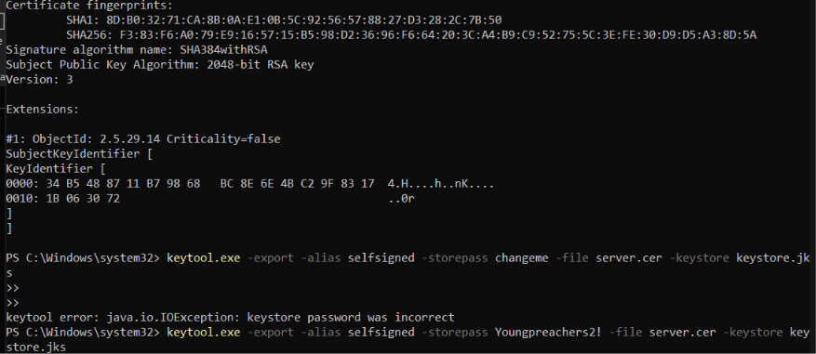

Deploy Cipher
Insert a screenshot below of the checksum verification.

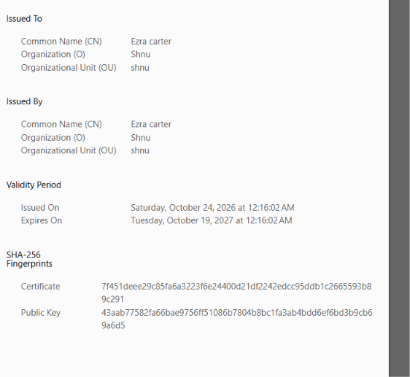

Secure Communications
Insert a screenshot below of the web browser that shows a secure webpage.

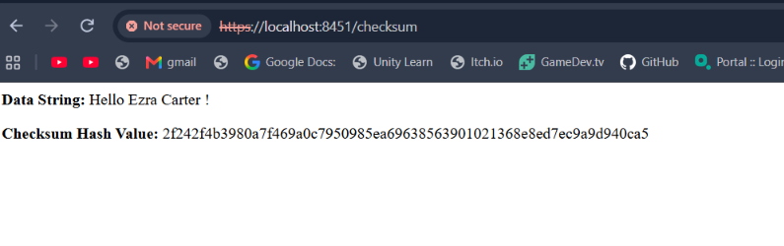

Secondary Testing
Insert screenshots below of the refactored code executed without errors and the dependency-check report.

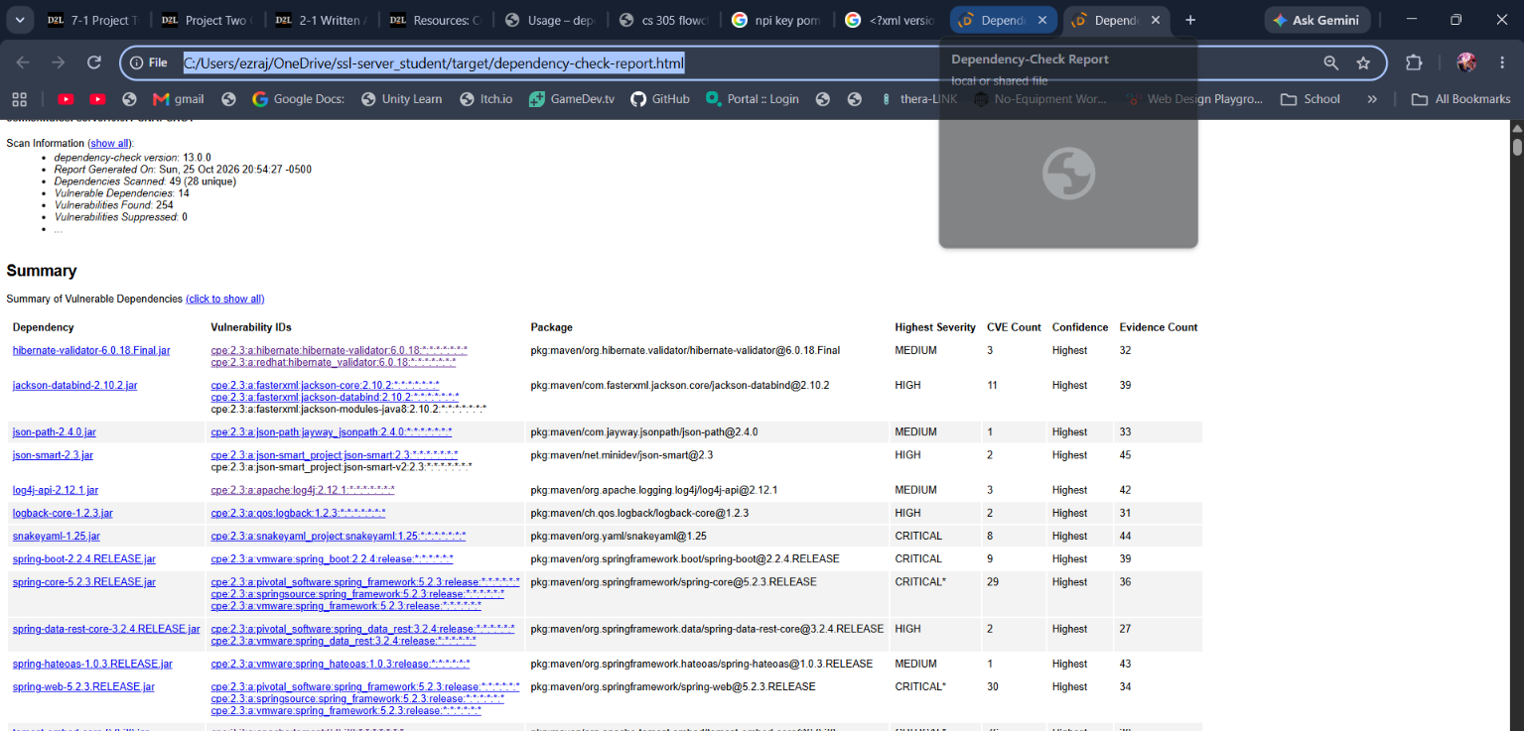

Functional Testing
Insert a screenshot below of the refactored code executed without errors.

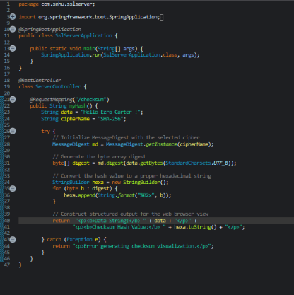
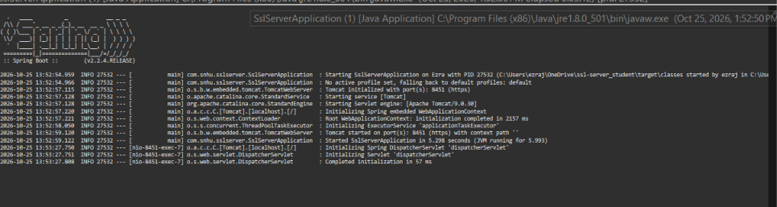

Summary

The code in general preforms at multiple key aspects of the projects. For starters we have two separate hashes going in with both validating the site in general as well. By using the HTTPS protocol, I can encrypt data being sent from and to the server. This helps protect my code from outside influences as well protect my server from nefarious actors. Furthermore, I implement a try catch statement this is to ensure any errors that arise in the try block does not impact the code further and instead fails as designed. I utilized code quality making sure my code works and shortcuts aren’t taken. This is to further cause my code to excel and protect my code. Because I’m not taking custom player input, I do not need to worry about validation however treated anything entered by the user as malicious can help with this. Finally I encapsulated this by putting the program within it’s own function allowing for us to call for this later on in different sections if need be.

Industry Standard Best Practices

As the scope and ideals of our project grow, keeping in line with industry’s best practice becomes a more crucial step as your project grows. There are a variety of reasons, but the largest in my opinion is to avoid technical debt and allow your code to become readable for future software developers looking to work on the application in the future. In this example using a Try catch statement is fundamental in preventing errors from occurring this is because if the program fails a predictable action is instead done executed in order to prevent further chaos and harm. By ignoring this we can open the flood gates for hackers to exploit my codes failing in conjunction with other code failing to gain control of the program.

